

**PROJECT REPORT**

**COMPUTER NETWORKS**

**MULTICLIENT CHAT APP**

Group members

12MSE1086 Kunwarjeet Singh

12MSE1037 Abhiraj Singh

**ABSTRACT**

There are 100s of Chat Application in use today like WhatsApp , HangOuts , Facebook Massenger each one is free of use but requires internet connection. In our Project we have created Multi Client Server Chat System where users can chat with anyone using their IP Address. Once App has to run on server , then any client can connect to it and start chatting. Finally we will demonstrate project using **Desktop app** and **Android Application.**

**Networking Basics**

Computers running on the Internet communicate to each other using either the Transmission Control Protocol (TCP) or the User Datagram Protocol (UDP), as this diagram illustrates

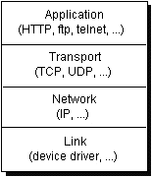

When we write Java programs that communicate over the network, you are programming at the application layer. Typically, you don't need to concern yourself with the TCP and UDP layers. Instead, you can use the classes in the java.net package. These classes provide system-independent network communication. However, to decide which Java classes your programs should use, you do need to understand how TCP and UDP differ.

**Running Procedure**

* In our chat first we will run the application on server.
* Then we will again run the application on client we want.
* The application will ask the IP adderss of the Server.
* The user will enter the ip address of server.
* Then the user will enter his name. A message will be displayed that this user has entered the chat application.
* Similarly any other user who enters the same ip adderss can also enter the chat room. The users must be connected to the same network to use the application.

**Software Tools Used**

Netbeans 8.0

Eclipse Android Developers

**Snapshots**

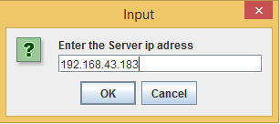 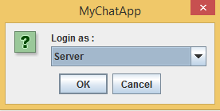

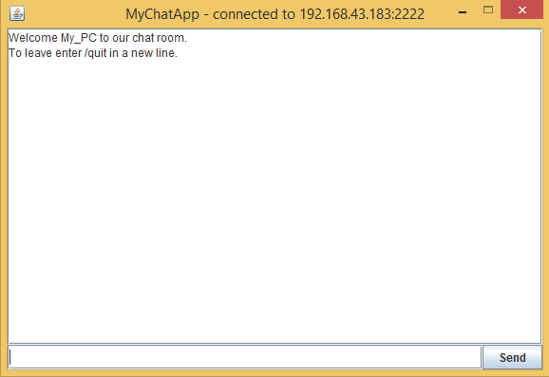

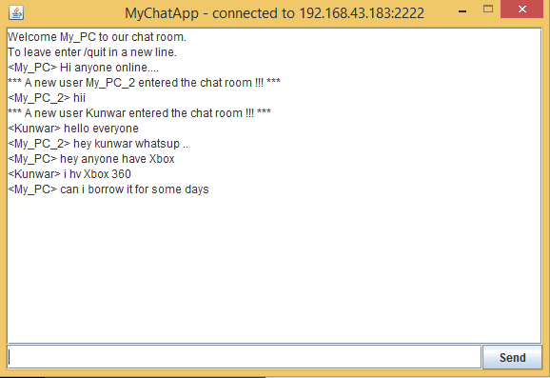

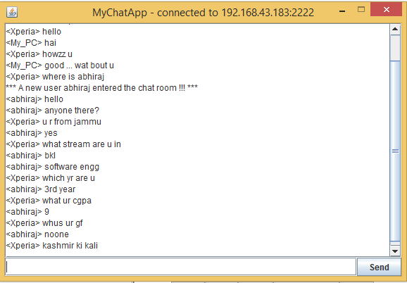

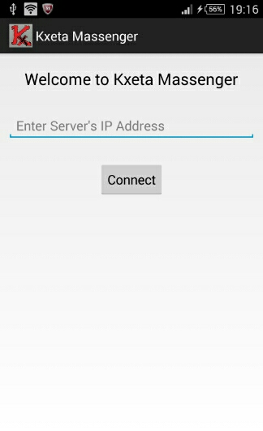 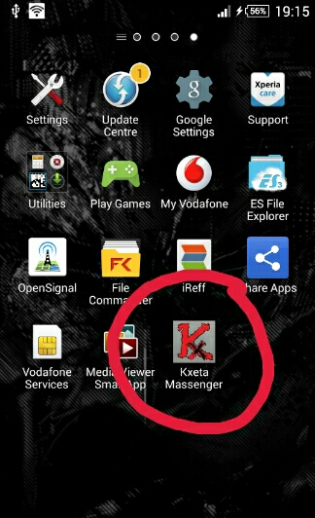

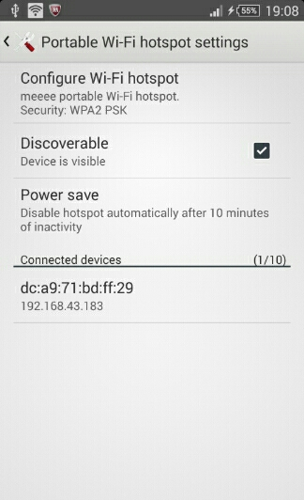 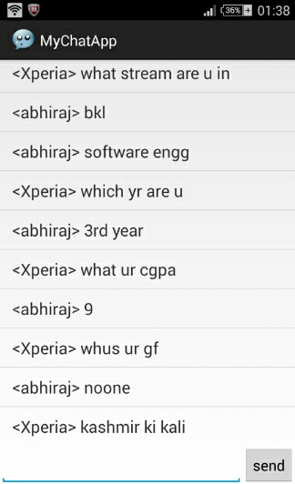

** Developed By**

**Team KXeta**